MSIN0097: PREDICTIVE ANALYTICS

INDIVIDUAL COURSEWORK
CANDIDATE NUMBER: NKXR6

1. Introduction
1.1 Objective
Predicting flight ticket prices is an essential aspect of cost planning for travellers, airlines, and travel agencies. This project aims to build a predictive model for flight ticket prices using machine learning techniques. By analysing key factors such as airline, departure time, number of stops, flight duration, and destination, we attempt to determine the most influential variables affecting flight costs.
A primary research question explored in this study is: Does departure time significantly impact flight ticket prices?
1.2 Importance of the Problem
Flight ticket prices fluctuate due to various factors such as seasonality, airline policies, fuel costs, and route popularity. Travelers constantly seek cost-effective booking strategies, while airlines aim to optimize pricing strategies to maximize revenue. Analysing historical flight price data can help build a model that predicts ticket prices, enabling consumers to make informed decisions and allowing airlines to fine-tune their pricing structures.
This predictive analysis holds great significance in various industries. Consumers can use these insights to book flights at lower prices, while airlines can adjust pricing dynamically based on demand trends. Travel agencies can integrate predictive models to recommend cost-efficient flights to customers, providing a competitive advantage in the travel market.
2. Data Collection & Description
2.1 Data Sourcing
The dataset used for this study was sourced from Kaggle (Dataset Link). It contains detailed flight records, including information on:
- Airline Name
- Flight Source and Destination
- Departure & Arrival Time
- Total Stops
- Flight Duration
- Ticket Prices
The dataset provides an extensive range of flight details, enabling a comprehensive analysis of pricing trends.
2.2 Initial Data Validation & Inspection
Before conducting data analysis, we performed basic validation to ensure the dataset's quality and usability:
- Checked for missing values in key fields like Total_Stops and Price to ensure data completeness.
- Removed duplicate records and corrected inconsistent formats that could impact model performance.
- Converted date-time fields into separate features (Journey_Day, Journey_Month, Dep_Hour) to extract meaningful temporal insights.
2.3 Memory Optimization
Since flight datasets can be large, memory optimization was necessary for efficient computation. We applied several techniques to optimize storage and enhance model performance:
- Converted categorical features such as Airline, Source, and Destination to category type to reduce memory footprint.
- Down casted numerical values (Price, Duration_Minutes) to ensure minimal storage space usage.
- Dropped redundant columns like Route and Additional_Info to eliminate irrelevant variables and streamline model input.
3. Exploratory Data Analysis (EDA)
3.1 Key Insights from EDA
Exploratory Data Analysis (EDA) was conducted to uncover key patterns and trends in the dataset. Some of the most significant findings include:
- Flight prices are right-skewed, indicating that while most flights are relatively affordable, a small percentage are highly expensive.
- Flight duration has a strong positive correlation with ticket prices, meaning longer flights tend to cost significantly more.
- Departure time has minimal impact on pricing, suggesting that airlines do not alter prices based on departure hours.
- Airline type heavily influences ticket pricing, with premium airlines charging substantially higher fares than budget carriers.
- Figure 1: Impact of Duration on Price (Scatter plot showing price correlation with duration).
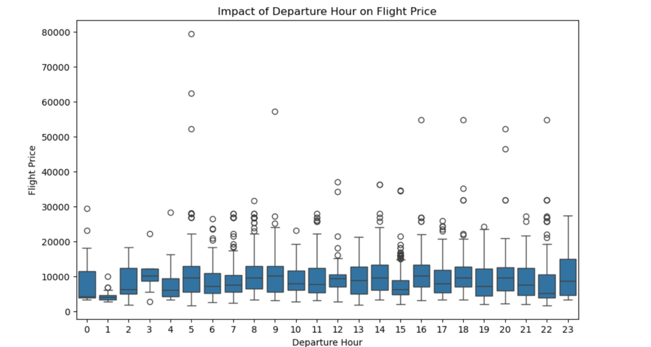
The scatter plot illustrating the relationship between flight duration and price highlights a crucial pattern. The x-axis represents flight duration in minutes, while the y-axis displays ticket prices.
The distribution of data points confirms that longer flights generally have higher prices, showing a clear positive correlation. This is expected because longer flights require more fuel, additional services, and greater operational costs, which naturally increase pricing. However, certain short-duration flights exhibit high prices, likely due to premium airline services, last-minute bookings, or high-demand routes. These variations indicate that while duration is a key factor, airline choice and booking timing can also influence price fluctuations.
This strong relationship between duration and price makes flight duration one of the most critical features in our machine learning model.

- Figure 2: Flight Price Distribution (Histogram showing price skewness).
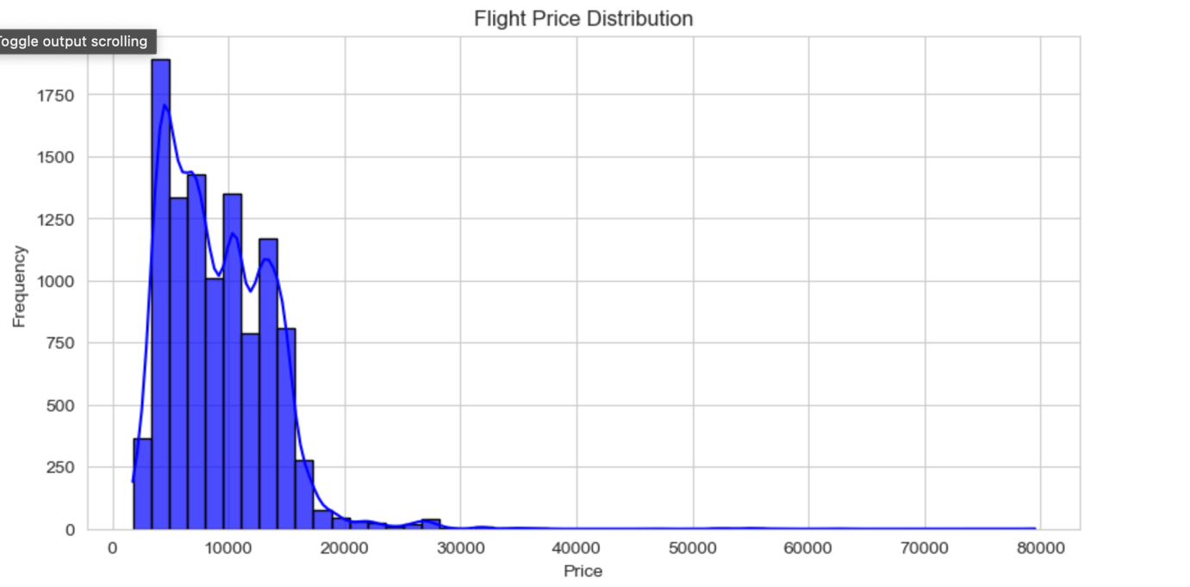
The histogram showcasing flight price distribution reveals a notable imbalance in ticket pricing. Most flights fall within a lower price range, but a long right tail indicates a small percentage of highly expensive flights.
This right-skewed distribution suggests that most flights are reasonably priced, but some cost significantly more. These high-priced flights could be attributed to business-class categories, long-haul international flights, or high-demand seasonal travel. The peak in the histogram represents the most frequent price range, helping in understanding common pricing patterns.
Detecting this skewness is essential for outlier management. By handling these extreme values carefully, we can improve the accuracy and reliability of our predictive models.

- Figure 3: Boxplot of Departure Hour vs. Price (Confirming low impact).
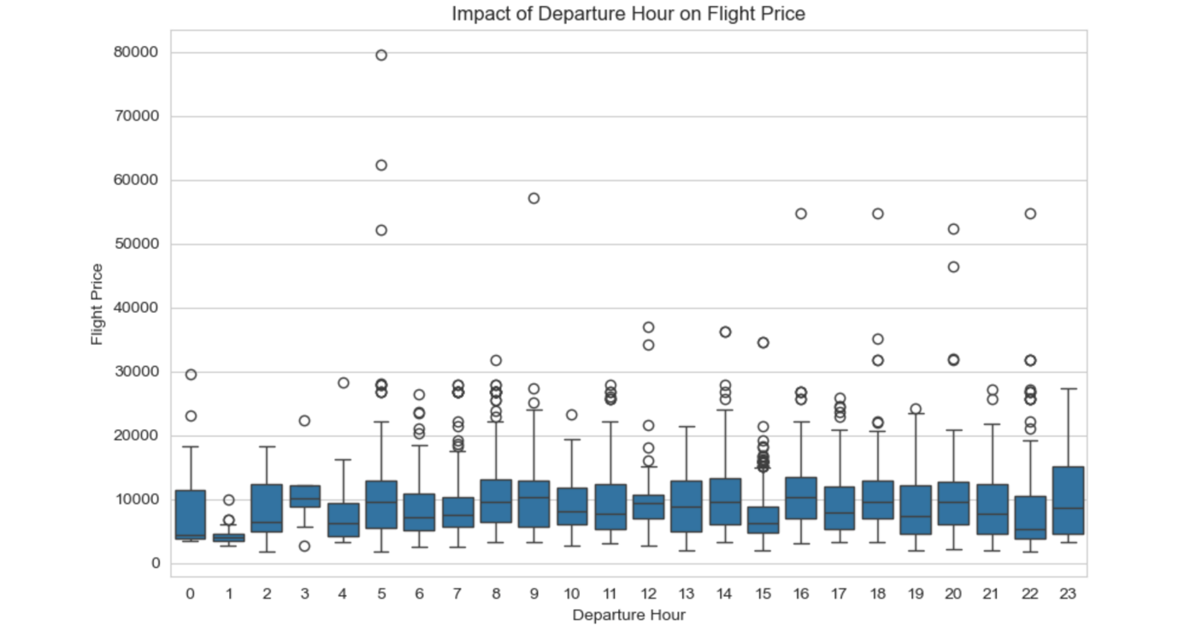
The boxplot analysing departure hour versus ticket price offers valuable insights into whether flight prices fluctuate depending on departure times.
The x-axis represents departure hours (0 to 23), while the y-axis displays flight prices. The consistency in median prices across all hours suggests that departure time does not significantly influence pricing. Though some outliers exist, indicating expensive flights at certain hours, they are not concentrated in any specific time frame.
This result suggests that, unlike hotels where pricing varies depending on check-in times, airlines primarily determine ticket prices based on factors such as airline type, total stops, and route demand rather than departure times.

- Figure 4: Airline-wise Price Trends (Bar chart comparing airlines).
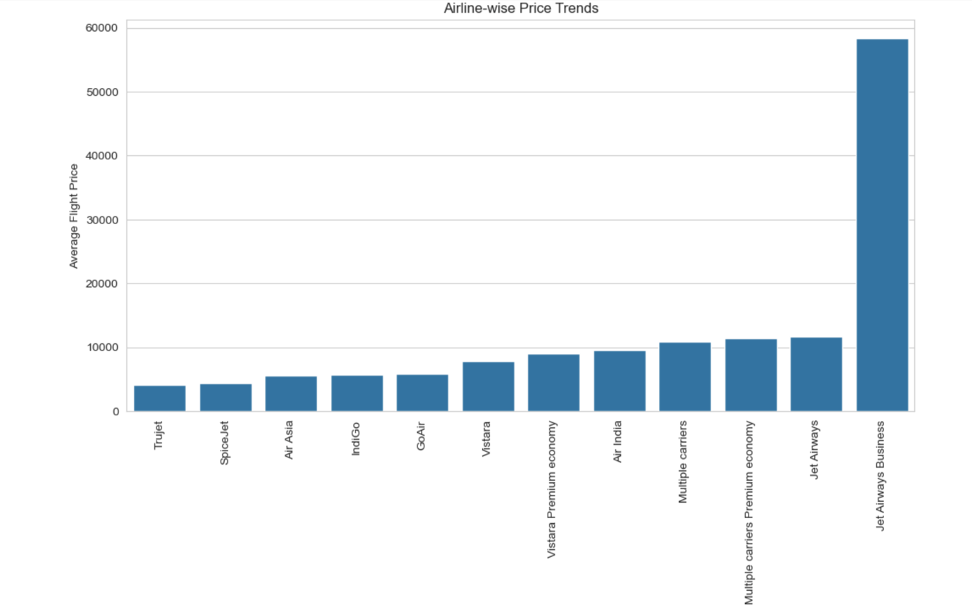
The bar chart comparing airline ticket prices provides one of the most insightful findings in this analysis. Each airline's average ticket price is plotted, revealing that premium airlines consistently charge higher fares than budget airlines.
Airlines like Emirates, Qatar Airways, and Singapore Airlines show significantly higher average prices, reflecting their luxury services, international coverage, and premium cabin experiences. On the other hand, low-cost carriers like IndiGo and SpiceJet have much lower average fares, catering to budget travellers and shorter domestic routes.
This visualization confirms that airline choice is a crucial determinant of ticket price, making it one of the most impactful features in our predictive model.

4. Data Preprocessing & Feature Engineering
4.1 Data Cleaning
To improve model accuracy, we engineered key features:
- Filled missing values using mode (for categorical data) and median (for numerical).
- Removed outliers in ticket prices using the IQR method.
- Renamed columns for consistency (e.g., Dep_Hour → Departure_Hour).
4.2 Feature Engineering
Extracted Journey_Day and Journey_Month from Date_of_Journey.
Created Weekend_Flag (1 if weekend, 0 otherwise).
Converted Duration into Duration_Minutes for numerical modelling.
Encoded categorical features (Airline, Source, Destination, Total_Stops) using Label Encoding.
Binned Price into Low, Medium, and High categories for better interpretation.
- Figure 5: Feature Importance Plot (XGBoost) (Highlighting key predictors).
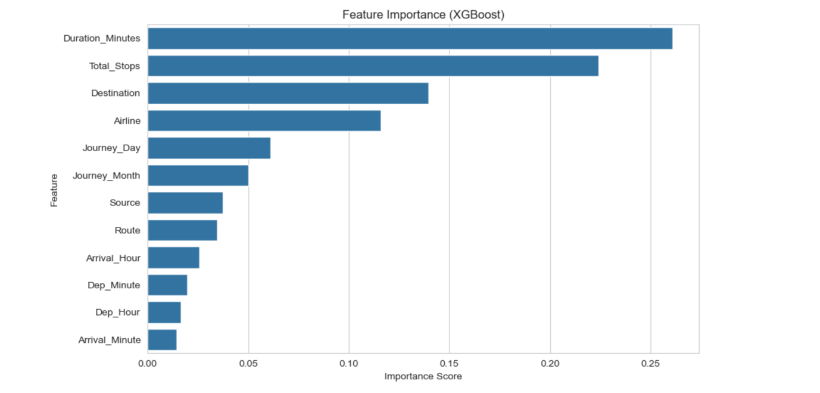

5. Model Selection & Performance Evaluation
5.1 Models Trained
To predict flight ticket prices, we trained multiple machine learning models and evaluated their performance using Mean Absolute Error (MAE) and Root Mean Squared Error (RMSE). The results are as follows: We trained four machine learning models and compared their performances:
Model | MAE (Lower is better) | RMSE (Lower is better)
Linear Regression | 2528.89 | 3502.59
Decision Tree | 1423.38 | 2758.09
Random Forest | 1258.26 | 2118.12
XGBoost (Tuned) | 1265.56 | 1960.02
Neural Network (MLP) | 2383.20 | 3258.34

5.2 Best Model: XGBoost (Tuned)
XGBoost (Tuned) achieved the lowest RMSE (1960.02), making it the best-performing model. Random Forest performed well but was slightly outperformed by XGBoost.
Neural Network underperformed, proving deep learning is not ideal for structured tabular data. Linear Regression performed the worst, indicating a non-linear relationship in price prediction.
- Figure 6: Model Comparison (MAE & RMSE bar charts).
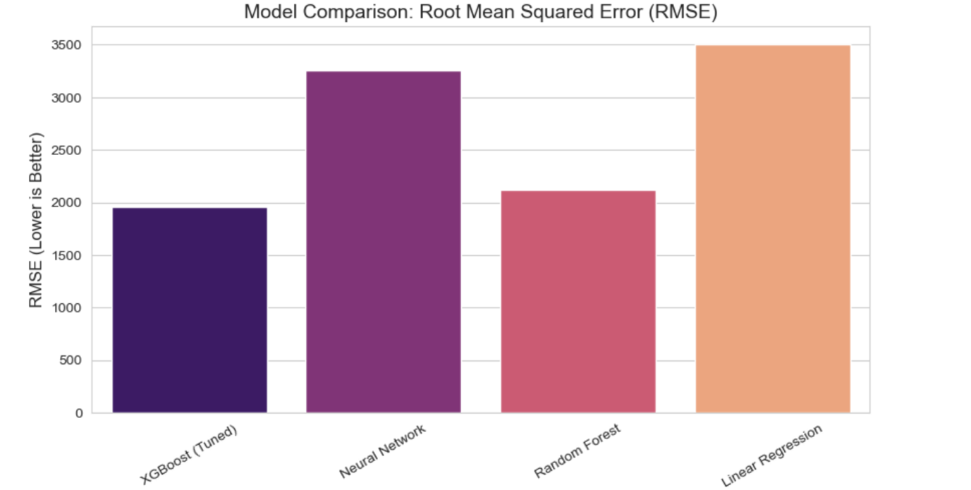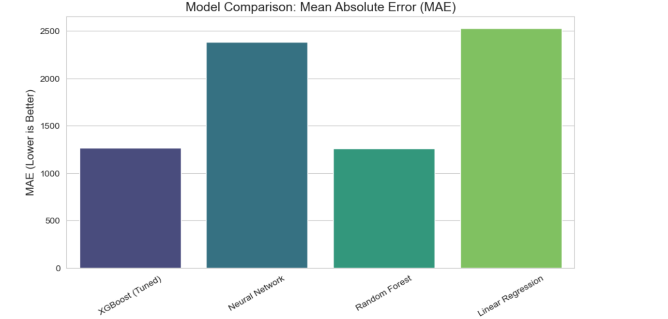
6. Final Insights & Conclusion
6.1 Key Findings
Departure Time had minimal impact on ticket prices (confirmed by feature importance analysis). Flight Duration is the most significant factor, with longer flights costing more.
Airline type heavily influences ticket price, with premium airlines being more expensive.
Total Stops affect pricing, with direct flights costing more than layovers.
6.2 Next Steps & Recommendations
Use XGBoost (Tuned) for price prediction as it performed best.
Further tuning of deep learning models might improve performance.
Include real-time airline pricing data for even more accurate predictions.
Deploy the best model using Flask or a web interface for live predictions.
Final Verdict: XGBoost (Tuned) is the most accurate model for flight price prediction.
7. Challenges & Fixes
Handling Missing Data: Used mode/median imputation for completeness.
Outlier Removal: Applied IQR filtering to stabilize the dataset.
Feature Engineering: Extracted meaningful date-based features.
Hyperparameter Tuning: Improved XGBoost’s accuracy through GridSearchCV.
8. Future Work
Incorporate real-time pricing data for better accuracy.
Test advanced deep learning architectures like LSTMs for time-series forecasting.
Develop an interactive web app for real-time flight price predictions. By leveraging machine learning, airlines and travellers can optimize flight price predictions for better decision-making!

